Junle Li

Aug 10, 2020

Fundamentals of Programming: Python

Assignment05

**Introduction**

This week’s assignment is to find examples of Pickling and Error Handling codes online, then work with it and explain what it does

**Step 1: Pickling**

**code:**

import pickle

# input

make = input('Enter the make of the car: ')

model = input('Enter the model of the car: ')

list1 = [make, model]

# write

list_file = open('data.dat', 'wb')# open the file in write binary mode

pickle.dump(list1, list_file)# serialized data and write data into the file

list_file.close()

# read

list_file = open('data.dat', 'rb')

list2 = pickle.load(list_file)# reads data from the binary file

print('My Fav cars are:', list2)

**Result:**

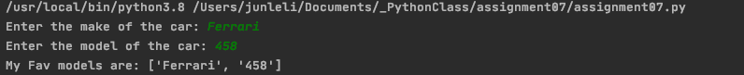

So the pickling module is to serialize the python objects, and save it using pickle.dump() under the “wb” mode which stands for write binary, and it could also unpickle and read serialized data from binary files using pickle.load() under “rb” mode which stands for read binary.

**Step 2: Error Handling**

**Code:**

Try: # try to open the file first

f = open("1.txt", "r")# opens file to read

try:

content = f.read()

print(content)

f.close()

except NameError as error:

print("Error:%s" % error)

except FileNotFoundError as error:

print("Error:%s" % error)# returns error when the file is not found

**Result:**



For error handling, I choose a file not found error from the internet because I notice it happens to me sometimes when I was coding, and even when I search files on my computer. Typos happened so it would be a good idea to have a try except method to handle the error and return it to the user.

**Conclusion**:

Error handling is a good tool especially for better user experience when they use your code and they could notice the error if your code handles error actively rather than leaving the user clueless. As for the pickle function, I still quite confused about it as the book says it is not secured so I will need to look into it to see when we should use pickle module.